Mitosis – four main phases

1. PROPHASE | Chromatin threads condense to become chromosomes (chromosomes are two sister chromatids held by a centromere) – nuclear membrane disintegrates, and nucleolus disappears – mitotic spindle forms and the spindle fibres attach to each chromosome at its centromere – two centrosomes containing two centrioles each move to opposite poles of the cell
2. METAPHASE | Chromosomes move to the centre of the cell and line up along the equator of the cell (equator can also be referred to as metaphase plate) – centromeres of chromosomes are aligned on equator and the centrioles are located at opposite poles of the cell
3. ANAPHASE | Spindle microtubules shorten and pull on the centromeres – sister chromatids separate and are pulled to opposite poles – at the end of the phase each pole has an identical set of maternal and paternal chromosomes (DNA replication took place in the S phase during interphase)
4. TELOPHASE | Chromosomes decondense to form chromatin – two new nuclear membranes form, one for each new daughter cell – nucleoli reappear, and spindle apparatus disappears – cell elongates, and a cleavage furrow forms to become ready for cytokinesis

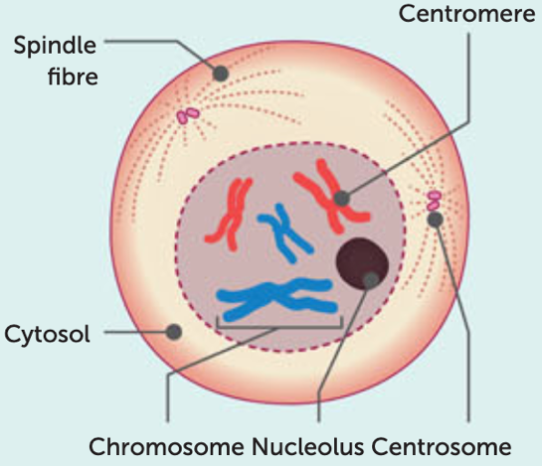 | 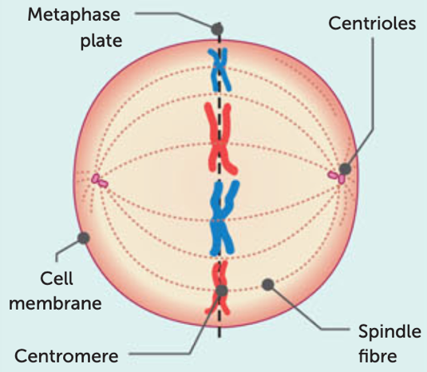
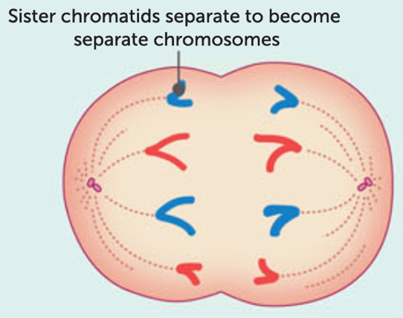 | 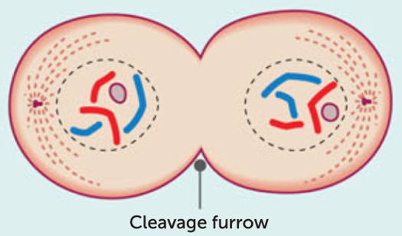

*NOTE: Interphase is the period between mitotic division where DNA replication takes place – not exactly a part of mitosis directly, but worth mentioning in responses – interphase can be described using the cell cycle and the phases within the cell cycle

